SMART WASTE BIN MONITORING & COLLECTION OPTIMIZATION SYSTEM

Introduction
Efficient waste management is a critical requirement for modern smart cities. Traditional garbage collection methods rely on fixed schedules rather than actual waste load, leading to unnecessary fuel consumption, overflowing bins, delayed pickups, and resource misallocation. To address these challenges, an IoT-based Smart Waste Bin Monitoring and Collection Optimization System is proposed. This system continuously monitors the fill levels of waste bins across various city zones, automatically notifies municipal authorities when bins are nearly full, and generates optimized garbage collection routes similar to real-time ride navigation systems like Rapido or Uber.
The solution is designed to be cost-efficient, low-power, scalable, and practical for real deployment in Indian city environments, where bins may be placed in shaded, dusty, or crowded areas. By utilizing VL53L1X Time-of-Flight sensors, STM32WL LoRaWAN nodes, long-range communication, MQTT-based cloud processing, and smartphone GPS tracking, the system ensures reliable monitoring and operational automation while minimizing maintenance needs.

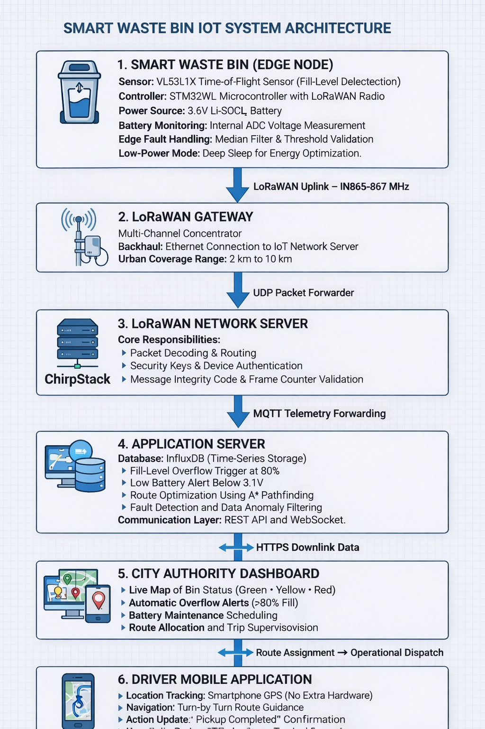
- System Architecture
The system architecture provides an end-to-end framework for detecting waste bin fill levels, transmitting data to the cloud, alerting authorities, and enabling real-time route optimization for garbage truck drivers. It integrates sensing hardware, edge processing, low-power communication, cloud intelligence, and dashboard visualization into a workflow.

  - Hardware Layer: Sensors & IoT Devices
Component | Selected Model | Why This is the Best Practical Choice | Why Not Other Options
Fill-Level Sensor | VL53L1X Time-of-Flight | Accurate in dust/humidity, works on irregular garbage surfaces, low power, ToF stability confirmed in ST datasheet | Ultrasonic sensors give errors due to plastic bags, vapor, uneven reflections; require maintenance
IoT Controller | STM32WL (MCU + LoRaWAN integrated) | Ultra-low power, built for long battery life, fewer components → higher reliability, industrial IoT grade | ESP32 + LoRa has higher current draw, more wiring, lower reliability for long-term deployment
Power Supply | Li-SOCl₂ 3.6V Industrial Battery | 3–5 year life, negligible self-discharge, used in global utility meters; no charging/solar needed | Solar panels are impractical in shaded bins; Li-ion requires charging & degrades faster
Housing | IP65 outdoor enclosure | Dust/water resistant, protects electronics from municipal environment | Non-IP housings degrade faster and increase failures
Battery Health Monitor | Voltage Divider + STM32WL ADC | Monitors battery voltage in real time & sends health flag | Dedicated BMS would add cost and power overhead per bin

  - Communication Method (Selected & Rejected Options)
Network Type | Verdict | Explanation
LoRaWAN | Selected | 2–10 km city coverage, low power, no SIM cost, ideal for 500–1000+ nodes
Wi-Fi | Not preferred | Short range, high interference, unsuitable for battery-powered street deployment
NB-IoT / SIM IoT | Not preferred | Monthly SIM cost per bin + higher idle drain, costly at scale
Wi-SUN / Zigbee Mesh | Not preferred | Requires repeaters and power nodes; over-complex for open-area bins
Final Choice: LoRaWAN for bin nodes → MQTT for uplink → HTTPS for dashboard.

1.3 Cloud & Edge Computing Strategy
Task | Location | Why
Fill calculation, battery check, noise filtering | Edge (STM32WL) | Reduces transmissions → saves battery; improves accuracy
Alerting & data storage | Cloud | Heavy logic & multiple zone processing
Route planning & visualization | Cloud Dashboard | Provides real-time control room view

1.4 Dashboard & Visualization (For Authorities)
- Map showing color-coded bins:
- 🔴 –60% (Normal)
- 🔴 60–80% (Monitor)
- 🔴 >80% (Collect Soon)
- Real-time alerts & notifications
- Live garbage truck tracking (via driver smartphone GPS)
- Route suggestions like Rapido/Uber based on priority bins
- Accessible through HTTPS login portal

2.Data Flow Design
The data flow in the Smart Waste Bin Monitoring System follows a structured uplink pipeline from the bin to the cloud, and a controlled bidirectional communication flow from the cloud to users (dashboard and drivers). This ensures optimized battery usage, low-power radio operation, and real-time operational visibility for authorities.
2.1 How Data Moves from Bin Sensors to Central Dashboard
LoRaWAN Gateway
Smart Bin (STM32WL +VL53L1X)
Fill Level %, Battery %

Task Assignment / Confirmation
HTPPS+Websocket
MQTT
UDP Forwarder
Driver Mobile App │
- Navigation & Confirmation
City Authority Dashboard
- Monitoring & Alerts
Application Server
Network Server
LoRaWAN Uplink

2.2 Protocols Used & Justification
Stage | Protocol | Why It Is Suitable
Bin → Gateway | LoRaWAN Uplink (IN865–867 MHz) | Long range, low power, ideal for battery + outdoor bins
Gateway → Network Server | UDP Forwarder | Lightweight, low latency packet movement, no overhead
Network Server → App Server | MQTT | Designed for IoT telemetry, scalable to 1000+ bins, low bandwidth
App Server → Dashboard | HTTPS | Secure access for city authority monitoring
Dashboard ↔ Live Updates | WebSocket | Real-time status changes without refreshing UI
Dashboard ↔ Driver App | HTTPS API | Task dispatch + pickup confirmation communication

2.3 Why These Protocols Are Used
- LoRaWAN: Works across large zones (2–10 km), low power, lowest cost for municipal deployments.
- UDP Packet Forwarder: Ideal for gateways, avoids latency introduced by TCP.
- MQTT: Best protocol for constant sensor updates, topic-based routing, and large-scale IoT.
- HTTPS/WebSocket: Real-time visualization + secure communication layer for authorities and drivers.

2.4 Summary of Data Flow Behavior
✔ Uplink only from bin → No downlink commands to node → Saves battery
✔ Real-time dashboards through WebSockets
✔ Drivers close the loop with task confirmation, not the device

3. Route Optimization Strategy
The Smart Waste Collection System uses a Zone-Based Clustering + A* Pathfinding approach for route optimization. This method ensures efficient navigation, reduced fuel consumption, and minimal collection delays while avoiding the complexity and cost of on-vehicle GPS hardware.

3.1 Rule-Based Logic
The system first identifies which bins require collection based on defined operational thresholds:
- Bins with ≥ 80% fill level are added to the High-Priority Queue
- Hazardous/organic waste bins are auto-prioritized
- Bins not collected for > 48 hours are escalated
- Re-routing is triggered if updated bin data changes priority
This prevents unnecessary trips, reduces fuel usage, and ensures timely management of critical waste bins.

3.2 Selected Optimization Method

Zone-Based Clustering + A* Pathfinding
Component | Function
Zone Clustering | Groups bins by geography to avoid long jumping routes
A* Pathfinding Algorithm | Computes the shortest viable route based on distance and cost
Smartphone GPS (Driver) | Live tracking that enables dynamic rerouting, like Rapido/Uber
Cloud Recalculation | Adjusts route if traffic or bin priority changes
This approach is chosen because it offers:
- Real-world performance in cities
- Low computational overhead
- Low deployment cost (no GPS hardware on truck)

3.3 Real-Time Routing Like Rapido/Uber
- No GPS module on garbage truck → cost saving
- Driver smartphone app provides live GPS coordinates
- Cloud compares position + bin priority and updates route
- If a bin becomes full mid-route, the system recalculates next stop
- This mimics the operational method of Rapido/Uber, where the driver device is the location source.

3.4 Why This Is the Best Option
Method | Result
Dijkstra | Accurate but slower for real-time updates
Greedy | Quick but not optimal for large zones
Genetic/TSP | Too heavy for municipal systems
A* (Selected) | Best balance of speed, accuracy, and cost
Therefore, the final accepted approach:
Zone-Based Clustering + A* Pathfinding using driver smartphone GPS for location updates.

4. Power Management Plan
Method | Purpose
Sensor Duty Cycling | Read every 30–60 min instead of continuous scanning
STM32WL Deep Sleep Mode | Reduces power to µA range during idle
Low-Power LoRaWAN Class A | Transmits only when needed → battery longevity
Battery Monitoring via ADC | Predictive maintenance before failure
Compact Packet Size (MQTT) | Less airtime = less battery drain

5. Reliability & Fault Handling
The system includes multiple reliability strategies to ensure accurate measurement, communication stability, and long-term field operation. Each risk is addressed with a practical engineering response based on component capabilities and real-world deployment conditions.
Reliability Risk | Detailed Response & Engineering Reasoning
False fill-level due to plastic bag blockage or irregular waste surface | The VL53L1X ToF sensor performs multi-sampling and median filtering to remove sudden spikes or false readings caused by loose waste. As per the STMicroelectronics datasheet, VL53L1X supports “multi-ranging & distance averaging” which enhances measurement stability in non-uniform reflection environments.
Moisture, dust, or particulate interference | The ToF sensor is mounted behind a transparent acrylic window, forming a sealed optical barrier. According to IP65 environmental standards, an acrylic enclosure prevents ingress of water jets, dust, and insects, reducing cleaning/maintenance. ToF technology is preferred because it is less affected by humidity compared to ultrasonic reflection loss.
Gateway downtime or network interruption | STM32WL firmware buffers data locally using onboard memory (Flash/SRAM). The node stores multiple readings offline and retries transmission after network restoration. LoRaWAN Class-A devices support scheduled retry windows, making it suitable for intermittent connectivity areas.
Power drop / Battery nearing end-of-life | A voltage divider + STM32WL ADC monitors battery voltage. When voltage falls below a defined threshold (3.1V for Li-SOCl₂ batteries), a “Low Battery Alert Flag” is added to the MQTT payload. Datasheets confirm stable voltage discharge curves, enabling predictive battery replacement scheduling.
Node failure or silence due to hardware issues | Each device transmits a heartbeat packet every 24 hours, even if no alerts are triggered. If a node does not check-in for >48 hours, the dashboard marks it as “Unresponsive,” helping maintenance teams locate failures proactively.
Wrong sensor readings due to environment conditions | Median-filter logic and threshold validation are applied at the edge. Cross-verification with bin weight sensing (future upgrade: load cells) enhances accuracy in special cases like decomposing organic waste expansion.

Conclusion for Reliability
The architecture ensures robustness through data filtering, enclosure protection, local buffering, power monitoring, and proactive fault detection. These measures are aligned with best practices for long-term smart city field deployments.

6. Scalability & Network Considerations
The system is designed to scale from a pilot deployment of 100 bins to a full municipal rollout of 1000+ bins with minimal architectural change.

6.1 Network Topology Choice
Topology | Verdict | Reason
Star Topology (LoRaWAN Gateway Model) | ✔ Selected | Long range (2–10 km), minimal nodes, suited for large outdoor zones, no routing overhead
Mesh Networks (Zigbee, Wi-SUN) | ❌ Not Selected | Node-to-node dependency causes failures, requires many repeaters, higher maintenance
Wi-Fi Based Topology | ❌ Not Suitable | Dense urban interference, power-hungry radios, infrastructure complexity

6.2 Why This Scales Effectively
- Each LoRaWAN gateway can support 500–1000 nodes depending on traffic frequency.
- Bins send data periodically (not continuously), reducing network congestion.
- MQTT broker & cloud infrastructure can auto-scale vertically (more CPU/RAM) or horizontally (cluster mode).
- Adding new bins only requires provisioning, not redesign.

6.3 Why Not Mesh Topology?
Issue in Mesh | Impact
Repeater dependency | One failed repeater can break entire chain
Higher node-to-node interference | Network grows unstable as devices increase
Power demand increases on intermediate nodes | Not suitable for battery-powered hardware
Indoor-origin technology | Zigbee/Wi-SUN are better for smart grids, not street trash bins

6.4 Gateway Planning for Real Deployment
Area Type | Recommended Infrastructure
Small town (5–10 km²) | 1–2 gateways
Mid-sized city | 3–6 gateways
Metro city (multiple zones) | 10+ gateways with sector partitioning
Placement on existing towers, street lights, municipal offices reduces installation cost.

7. Cost & Feasibility Discussion
Item | Approx Cost (INR)
VL53L1X ToF Sensor | ₹250 – ₹500
STM32WL LoRaWAN MCU Node | ₹600 – ₹1,200
Li-SOCl₂ 3.6V Battery | ₹300 – ₹450
IP65 Housing + Custom PCB | ₹300 – ₹500
Assembly, Connectors, Mounting | ₹100 – ₹200

Final Cost per Smart Bin Unit
₹1,550 – ₹2,450 per bin

Operational Cost
- No SIM subscription
- No charging/solar maintenance
- Gateway shared across all bins → reduces city rollout cost

Trade-Off Discussion: Accuracy vs Cost vs Scalability
Design decisions in the Smart Waste Bin Monitoring System are driven by the need to balance measurement accuracy, hardware and operational cost, and city-wide scalability. Since municipal deployments may involve hundreds of bins across large zones, each component must justify its purpose in terms of long-term feasibility.

Accuracy Trade-Off
Choice | Accuracy Benefit | Limitation
VL53L1X Time-of-Flight Sensor (Selected) | High accuracy on irregular waste surfaces; stable against dust/moisture; reliable depth measurement | Slightly higher cost than ultrasonic
Ultrasonic Sensor (Not chosen) | Lower initial cost | Accuracy drops with plastic bags, uneven trash, humidity & reflections, increasing field maintenance
Weight-based bin sensing (Future upgrade) | Very high reliability for organic waste | Costly + mechanical assembly → reduces scalability
Conclusion:
➡ The system sacrifices the lowest upfront cost to ensure higher long-term accuracy and reduced maintenance.
➡ This leads to better operational performance and fewer false alerts.
Cost Trade-Off
Cost Focus | Strength | Risk/Compromise
LoRaWAN + STM32WL (Selected) | No SIM cost, long battery life, best ROI for 500–1000+ bins | Requires gateway provisioning
NB-IoT SIM Based IoT | Real-time cellular connectivity | Recurring SIM charge per bin → cost grows linearly with scale
Wi-Fi Based Solution | Very cheap hardware | Short range, power hungry, unreliable outdoors, not scalable
Conclusion:
➡ The proposed system is not the cheapest hardware, but it is the cheapest to operate at scale, which matters more for cities.

Scalability Trade-Off
Architecture | Scalability Impact | Suitability
LoRaWAN Star Topology (Selected) | 500–1000 bins per gateway; low maintenance; low power traffic | Best structure for municipal deployments
Mesh Networks (Zigbee/Wi-SUN) | More nodes = more repeaters = more points of failure | Not suitable for outdoor battery-powered bins
Wi-Fi Cloud Systems | Works only in very small networks <20 bins | Not scalable due to range, interference & router dependency
Conclusion:
➡ The system is optimized for city-wide scale while keeping hardware count low and maintenance cycles predictable.

Final Trade-Off Summary Table
Priority | System Decision | Impact
Accuracy | ToF over Ultrasonic | Fewer false readings, lower lifetime maintenance
Cost | LoRaWAN over SIM devices | No recurring charges; low operational cost per bin
Scalability | Star topology over mesh | Supports 1000+ bins without communication collapse
Maintenance | Battery over solar panels | No panel cleaning, works in shaded areas, less field failure

Conclusion
The system intentionally selects components that offer long-term economic benefit rather than the lowest purchase price. The final design achieves an effective balance.The IoT architecture using VL53L1X ToF sensing, STM32WL LoRaWAN nodes, MQTT communication, cloud-based analytics, and smartphone GPS navigation delivers a practical, scalable, and cost-efficient solution. It minimizes maintenance, maximizes battery life, and supports city-wide implementation while avoiding unnecessary hardware or recurring communication charges.

